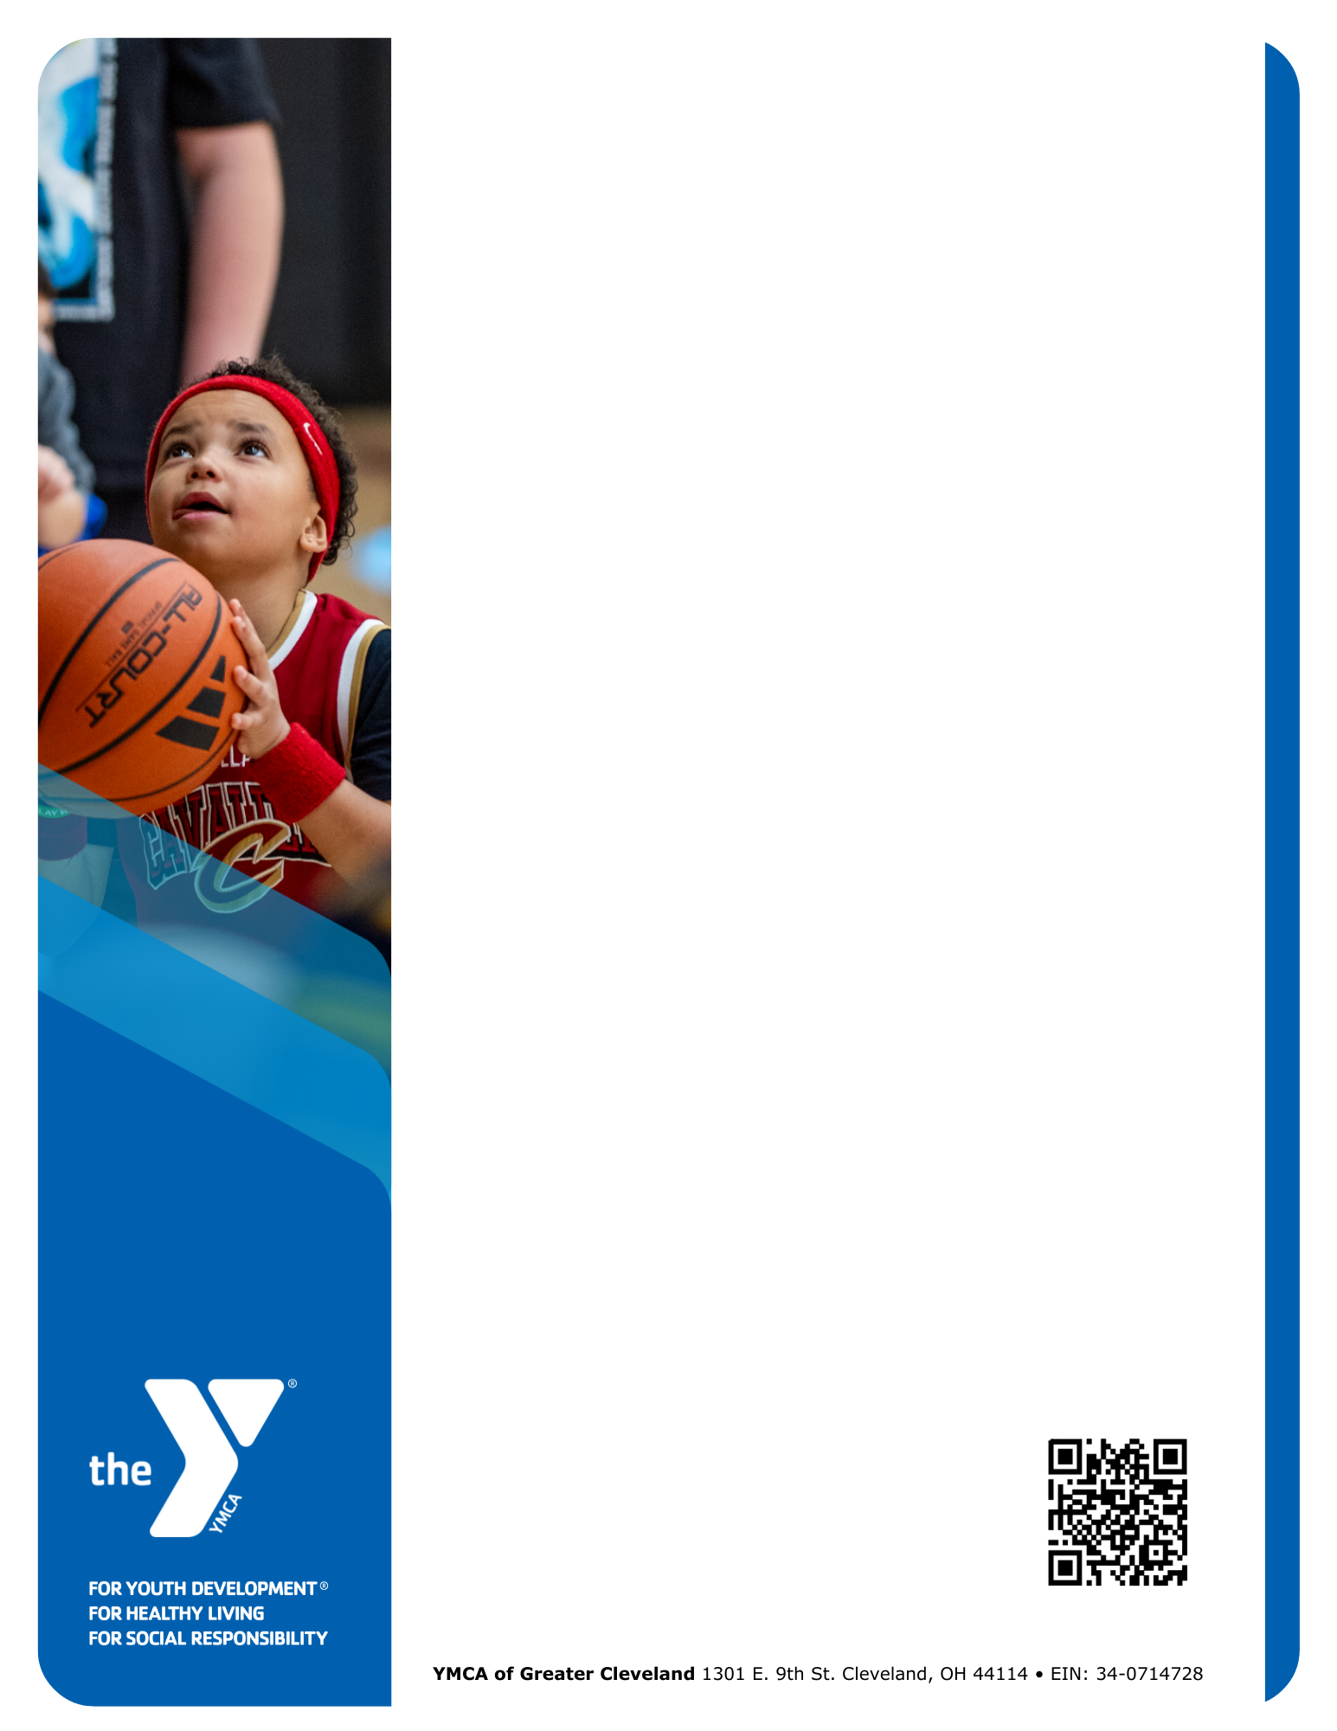Dear [Recipient Name],

As a neighbor of the [Branch Name] YMCA, you help make our community stronger. Every day, the YMCA connects children, families, and seniors to essential programs that promote well-being and **build a healthy spirit, mind, and body for all.**

Your support can make a lasting impact by:

* **Building connections** through programs that bring people together
* **Supporting youth and families** with education and   
  after-school programs
* **Promoting health and well-being** through fitness programs and safe spaces
* **Ensuring access for all** with financial assistance

When you give to the [Branch Name], **100% of your gift stays local** and directly benefits our shared neighborhood and community.

**Ways to give:**

* Scan the QR code below to give online
* Mail a check (payable to YMCA of Greater Cleveland, with [Branch Name] in the memo line)
* Provide an in-kind gift to support our programs and events

Your support ensures the YMCA remains a place where everyone in the [Branch Name] community belongs, thrives, and reaches their potential and beyond.

With gratitude for your consideration,

[Name]  
[Title]  
[Branch]

[Phone]  
[Email]

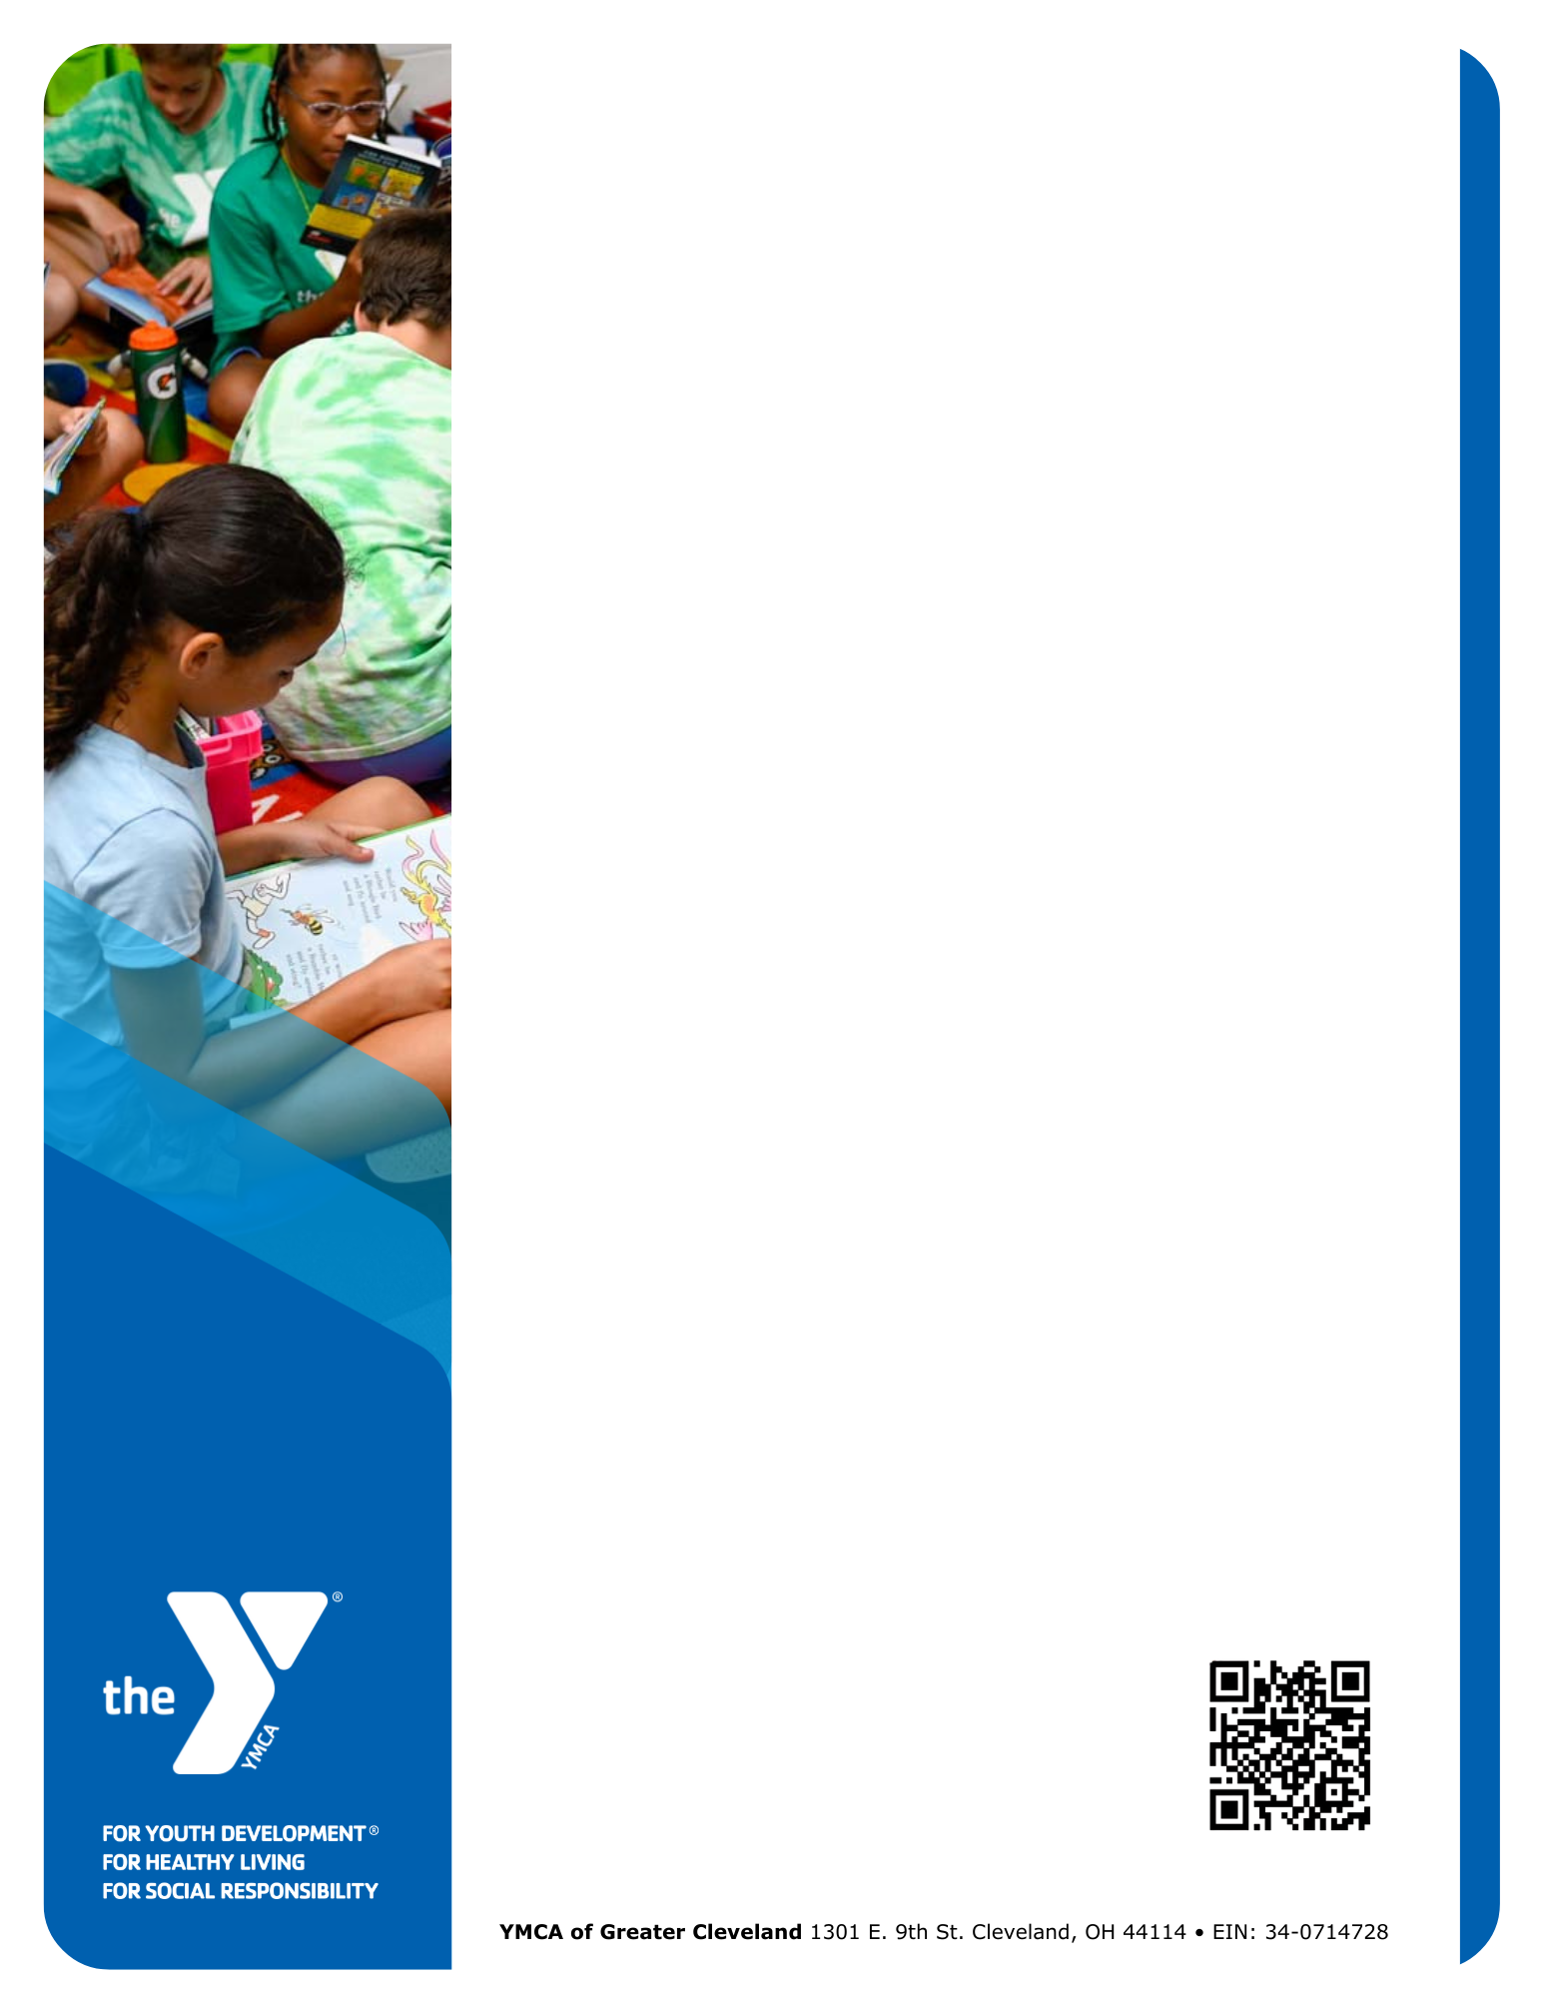Dear [Recipient Name],

As a neighbor of the [Branch Name] YMCA, you help make our community stronger. Every day, the YMCA connects children, families, and seniors to essential programs that promote well-being and **build a healthy spirit, mind, and body for all.**

Your support can make a lasting impact by:

* **Building connections** through programs that bring people together
* **Supporting youth and families** with education and   
  after-school programs
* **Promoting health and well-being** through fitness programs and safe spaces
* **Ensuring access for all** with financial assistance

When you give to the [Branch Name], **100% of your gift stays local** and directly benefits our shared neighborhood and community.

**Ways to give:**

* Scan the QR code below to give online
* Mail a check (payable to YMCA of Greater Cleveland, with [Branch Name] in the memo line)
* Provide an in-kind gift to support our programs and events

Your support ensures the YMCA remains a place where everyone in the [Branch Name] community belongs, thrives, and reaches their potential and beyond.

With gratitude for your consideration,

[Name]  
[Title]  
[Branch]

[Phone]  
[Email]

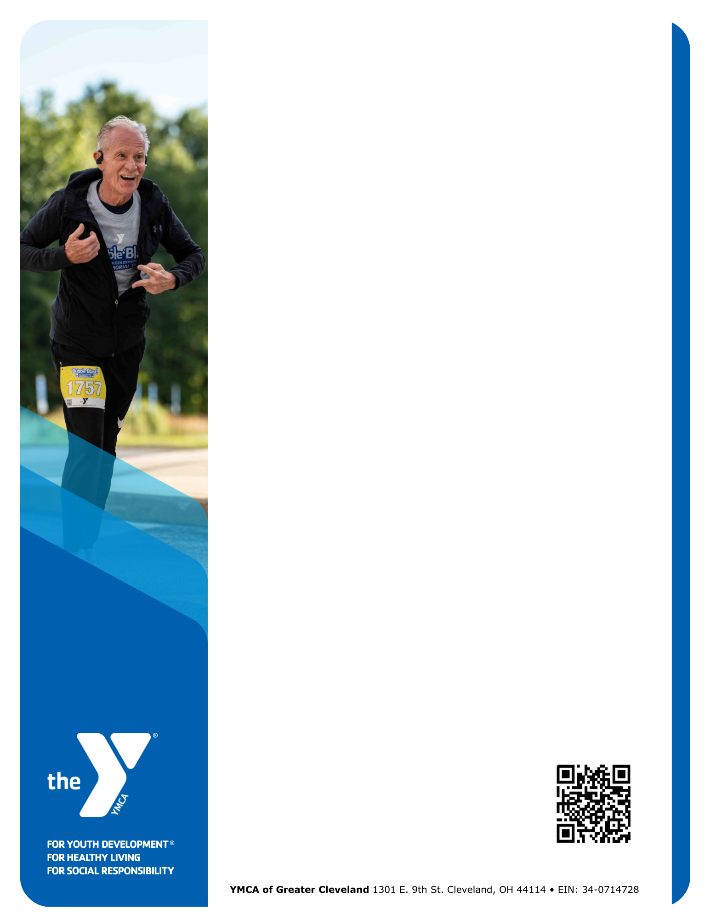Dear [Recipient Name],

As a neighbor of the [Branch Name] YMCA, you help make our community stronger. Every day, the YMCA connects children, families, and seniors to essential programs that promote well-being and **build a healthy spirit, mind, and body for all.**

Your support can make a lasting impact by:

* **Building connections** through programs that bring people together
* **Supporting youth and families** with education and   
  after-school programs
* **Promoting health and well-being** through fitness programs and safe spaces
* **Ensuring access for all** with financial assistance

When you give to the [Branch Name], **100% of your gift stays local** and directly benefits our shared neighborhood and community.

**Ways to give:**

* Scan the QR code below to give online
* Mail a check (payable to YMCA of Greater Cleveland, with [Branch Name] in the memo line)
* Provide an in-kind gift to support our programs and events

Your support ensures the YMCA remains a place where everyone in the [Branch Name] community belongs, thrives, and reaches their potential and beyond.

With gratitude for your consideration,

[Name]  
[Title]  
[Branch]

[Phone]  
[Email]

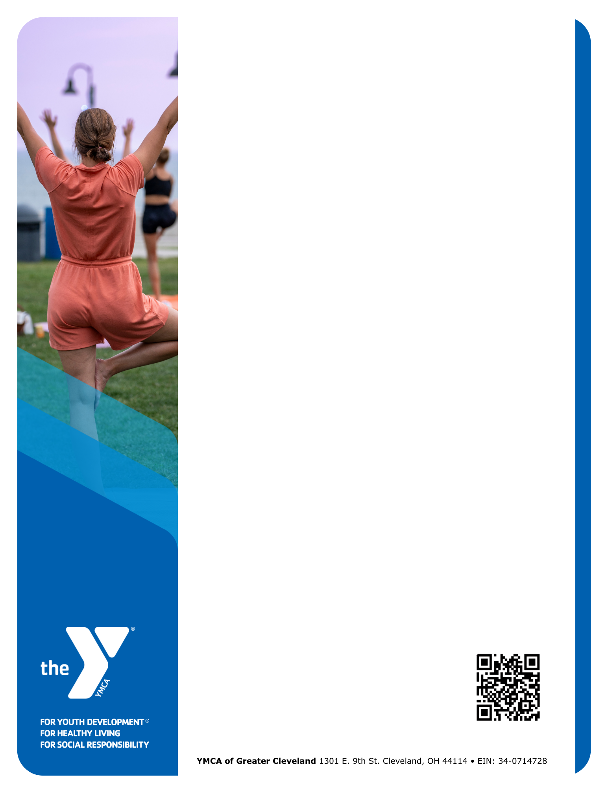Dear [Recipient Name],

As a neighbor of the [Branch Name] YMCA, you help make our community stronger. Every day, the YMCA connects children, families, and seniors to essential programs that promote well-being and **build a healthy spirit, mind, and body for all.**

Your support can make a lasting impact by:

* **Building connections** through programs that bring people together
* **Supporting youth and families** with education and   
  after-school programs
* **Promoting health and well-being** through fitness programs and safe spaces
* **Ensuring access for all** with financial assistance

When you give to the [Branch Name], **100% of your gift stays local** and directly benefits our shared neighborhood and community.

**Ways to give:**

* Scan the QR code below to give online
* Mail a check (payable to YMCA of Greater Cleveland, with [Branch Name] in the memo line)
* Provide an in-kind gift to support our programs and events

Your support ensures the YMCA remains a place where everyone in the [Branch Name] community belongs, thrives, and reaches their potential and beyond.

With gratitude for your consideration,

[Name]  
[Title]  
[Branch]

[Phone]  
[Email]